**Landing Page Outline**

**Target Audience:** Clients looking to learn more about hackathons and to hire a company to plan a hackathon for them.

**Change: Banner**

try out new banner image, try out new overlay, find a crowded hackathon picture

Remove: crowdsourcing innovation

**Clear message**

One sentence description of what a hackathon is and what we do

**Change: Gears**

* move up to right below the picture
* gears spinning, loose the background, make gears teal

**Benefits of a hackathon**

* 6 things hackathons can help accomplish

**Clear CTA -** Plan a hackathon button

**Why Hackworks?**

* Brief text description of why hackworks
* *(Testimonials)*
* Partners and sponsors

**Footer**

* Subscribe to Newsletter
* photo gallery
* social feed
* Contact: Address, Phone number, email
* terms
* privacy policy
* Media Section

**Website Content Needed**

**Landing Page**

1. Brief opening message - what a hackathon is and what we do
2. Benefits of hackathons / reason for hosting a hackathon:
   1. developer engagement
   2. corporate branding
   3. innovation
   4. product development & investment opportunities
   5. recruiting
   6. common good & community development
3. Why Hackworks?
4. Testimonials (need to get some from people we have worked with before)

**About us page**

Tab up top, furthest to the right

1. Hackworks Overview/Description

Sidebar would link to:

* Meet the Team (pics and mini descriptions)
* Contact (email, phone, office address, google maps integration to show location)

Later, we can add Careers specific pages like:

* Working at Hackworks (all the benefits etc.)
* Open positions
* etc.

**Expertise Page**

Tab up top, furthest to the left

1. Is a hackathon right for you? ( 6 pillars of hackathon benefits)
2. Services
3. What are our expertise

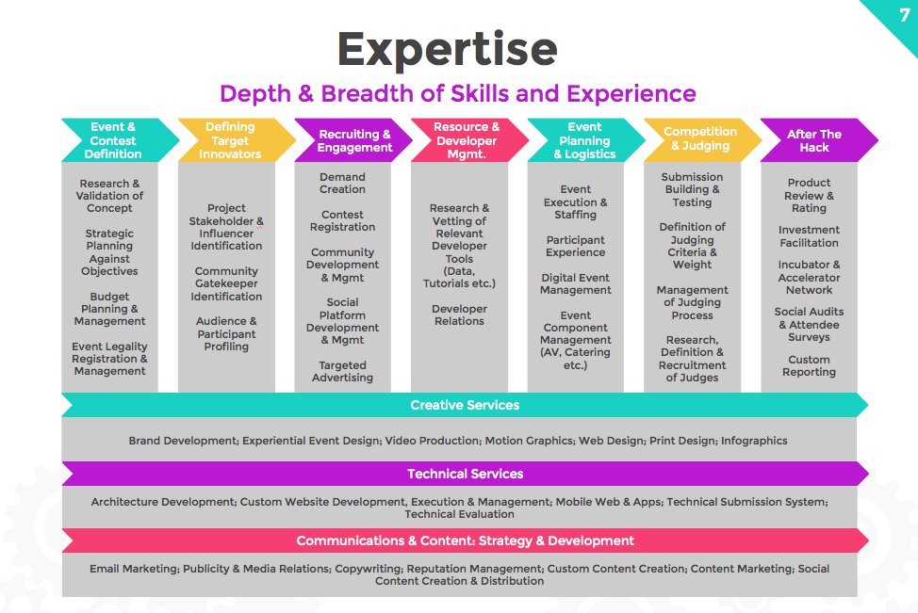

**Partners & Sponsors**

Tab up top, middle

1. One intro sentence, then Partner & sponsor logo’s of all GCAs and CODEs
2. Sidebar links to:
   1. GCA success case study
   2. CODE success case study

**Nav Bar**

* About us
* Expertise
* Successes

**Why host a hackathon?** (*notes we can use to create the text assets from the Cisco pitch)

In our app-centric world, even the traditionally analog landscape – like the taxi industry – is not exempt from disruption by technology startups.

Tech giants such as Cisco provide the foundation and building blocks of emerging technologies that startups use to springboard themselves into the limelight.

This is especially true for the Internet of Things industry because it is an all-encompassing next step with transformative potential.

Early engagement with startups and innovation communities through a hackathon will help Cisco continue to shape the future of the Internet and blaze a trail of firsts -- and lasts.

Developer Engagement

Hackathons build a bridge to the developer community, help establish two-way conversations between product and market and are a way to create and nurture an active developer community.

Developer Adoption & Immediate Feedback

Developer adoption is key to the success of an API program. Many established corporations owe their most recent wave of success at least in part to developers who helped proliferate their content across new distribution channels.

Corporate Branding

Chance to position Cisco as a technical leader by engaging in the social coding movement.

Innovation & Product Development

Hackathons are proving grounds for new ideas. They’re especially good tools to stimulate the creative and problem-solving juices of developers. Unlike their day jobs where risk-taking may be frowned upon, in a hackathon there is a low cost of failure.

And the time limit in a hackathon forces participants to distil their visionary concepts down to actionable solutions.

Outsiders can bring a fresh perspective to business challenges, as well as give an outside-in view of products and organization. Engaging with participants during the hackathon is an excellent way to get feedback on a recently released API: learn where developers get stuck, what they love and what suggestions for improvement they have.

Investment Opportunities

Participants often not only develop a prototype of an app but often its infrastructure as well. In addition, a hackathon can build a genuine business case for the app that justifies and facilitates further development.